Kennesaw State University

College of Computing and Software Engineering

Department of Computer science

CS7267-01

Machine Learning

Name of Assignment: Project

Name: Sreekanth Gopi

Email: sgopi@students.kennesaw.edu

KSU ID 001051267

Date: 12/12/2022

**EEG classification using Neural Network – An Application of Machine Learning in Classification of attention deficiency, to measure the effect of ChakraMarmaKosha Meditation-II**

Stress reduces attention span and is a common problem that impacts students’ academic performance as well as their self-efficacy in handling challenging situations. Meditation techniques have been proven to help manage stress levels. In the previous research, the author used Heart Coherence as the metric to show the impact of ChakraMarmaKosha Meditation (CM), a meditation on human energy centers, on reducing the stress level. In this research, a new version of CM-II, a guided psychotherapy and cognitive therapy meditation is being studied to analyze its impact on reducing attention deficiency among students. This study uses Electroencephalography (EEG) data as a metric to analyze electrical activities of the brain that contribute to attention deficiency. We use a neural network as a machine learning (ML) classifying algorithm to analyze the EEG data to measure the impact of CM-II on students’ attention deficiency.

Index Terms—ADHD detection, brain–computer interface (BCI), electroencephalogram (EEG) classification, Neural networks, Attention deficiency, Chakras, Marmas, Koshas, Meditation, breathwork.

INTRODUCTION

Attention is one of the cognitive skills that involve concentration, problem-solving, judgment, and language (read/write/speak) (Rego et al., K. 2010). Attention-Deficit Hyperactivity Disorder (ADHD) is a neuro-developmental disorder that is characterized by hyperactivity, inattention, and abrupt actions (Mohammadi et al., 2016), as well as certain degrees of inattentiveness, impulsivity, and hyperactivity subsets (Lambalgen et al., 2008). The development of ADHD is significantly influenced by chronic stress in children, and anxiety is a common co-morbidity of ADHD (Saccaro. et al., 2021). Chronic stress overworks the attention system, making it harder to devote attention (Liu, Q et al., 2020). According to the attention control theory, anxiety reduces the effectiveness of the inhibitory function and hinders attention (Eysenck MW, Derakshan, 2011). Most cases involve youngsters, while symptoms such as inattention can often appear later in the adult stage as well. Due to inattention, they lose their cognitive abilities, and it prevents them from academic achievement and social interactions. According to a 2011 poll by the Centers for Disease Control and Prevention, Atlanta, GA, 11% of American children between the ages of 4 and 17 had been diagnosed with ADHD (CDCP, 2016). 4.4% (i.e., 8,716,972 individuals), of adult ADHD, are diagnosed with ADHD in 2018 (Adler, 2021). In the US alone, ADHD costs the economy $122.8 billion in the US in 2018 (Adler, 2021) calculated from a total societal excess cost of $14,092 per adult. This includes healthcare, unemployment, productivity, caregiving, and premature mortality costs, much of this extra annual burden was made up of productivity and income losses because of ADHD-related absenteeism and ADHD-related presenteeism (Adler, 2021).

Early detection could reduce the substantial economic burden of adult ADHD, and this demands a new efficient detection method (Jafari, 2011). The diagnosis of ADHD is frequently made using diagnostic judgment in accordance with criteria from the DSM (Diagnostic and Statistical Manual of Mental Disorders) or ICD (International Classification of Diseases), which heavily depends on the parents' and educators' comprehension of the psychologists' questions and their candor in their answers (Meysamie and Mohammadi, 2011). To reduce the errors, various researchers have proposed and used more objective techniques, including EEG, for the diagnosis of ADHD. Since ADHD is dependent on brain function, bio-signals such as EEG is being researched for its performance. In this study, we intend to help students detect attention deficiency as early as possible using non-invasive technology and reduce the chance of ADHD. In addition, the students could improve their attention span and reduce hyperactivity.

In this study, we use a public EEG dataset of 60 ADHD and non-ADHD participants to train our developed machine learning classifier downloaded from the IEEE website: http://ieee-dataport.org. We used Multi-layer Perceptron (MLP), a feedforward artificial neural network in the classification of ADHD in each dataset.

Meditation is being used more and more for psychological problems. In the community of people with ADHD, meditation can be utilized as a method for improvement in attention (Krisanaprakornkit, T et al., 2010). In the next phase of this research, we would use this model to detect attention change in students after ChakraMarmaKosha Meditation II (CM II).

Research Questions:

* Can a machine learning algorithm detect accurately attention deficiency through spectral analysis of EEG data? (Phase 1)
* Does ChakaMarkaKosha Meditation II improve attention and increases students’ self-efficacy? (Phase 2)

Our contributions:

* Visualized the EEG data to see ADHD and non-ADHD brain scans using the MNE library in Python (Fig. 1, Fig.3).
* Extracted Alpha (α), Beta (β), and Theta (θ) band features (Fig. 4)
* Applied Neural Network in the classification of ADHD from scratch.
* Compared Multi-layer Perceptron (MLP) performance with other ML classifiers such as KNN, Naïve Bayes, SVM, Decision Tree, Random Forest, etc. to find the best classifier in Python.

The hypothesis is that CM-II improves attention, and increases students’ problem-solving skills, and self-efficacy. CM-II’s effect will be measured in an experiment primarily by classification of EEG data in phase II of the research.

**BACKGROUND:**

**ChakraMarmaKosha Meditation:**

CM-II is a sequel of CM in which the script focuses on improving an individual’s attention and self-efficacy. It guides the user through their emotional memories and releases past painful emotions associated with trauma. For instance, individuals with acute stress disorder may have significant psychological issues and distress that could have arisen from past stored emotions. In addition, they may also have distorted cognitions formed from convictions during trauma that keep them under stress. CM-II addresses these issues by guiding the listener through past emotional release and cognitive restructuring. The hypothesis is that CM-II improves attention, and increases students’ problem-solving skills, and self-efficacy. CM-II’s effect will be measured primarily by live EEG data in phase II of the research.

**Meditation and ADHD:**

Different body postures that the person adopts are called yoga asanas. Breathing exercises such as pranayama involve controlled inhalations and exhalations at a certain speed and force. Exercises that focus on breathing are also performed in silence while seated, either individually or in groups. On the other hand, meditation typically involves taking a seat apart for breathing and does not call for any active movements. The goal of the meditation-based practice is to deliberately calm the mind by separating thoughts from one another and/or focusing on one’s breathing (Kora et al., 2021). In a research conducted with 69 participants, meditation practiced for just 10 minutes each day for 10 days significantly reduced stress as measured by self-report questionnaires. 108 schoolchildren between the ages of 10 and 17 indicated that meditation improved verbal and spatial memory (Kora et al., 2021). In yet another 4-week study to assess mindfulness for children with ADHD aged 6 to 12 years old, it was discovered that meditation intervention dramatically decreased anxiety and sleep issues (Fried et al., 2022).

**Which Metric?**

In the previous research conducted by me on a meditation among 11 participants, it was found that ChakraMarmaKosha Meditation (CM), which focuses on one’s nerve plexuses (intersection of nerves) such as Cervical Plexus, Brachial Plexus, Lumbar Plexus, Sacral Plexus, and Solar plexus, helped the group reduce stress and improve immunity and health (Gopi, 2020). In CM, as in mindfulness meditation, we become mindful of various Chakras (energy centers) keeping our attention on the Marma points (nerve centers) and browsing through different Koshas or sheaths of consciousness. Further to this, I conducted another study in 2022 on different Vedic meditation practices such as Vedic Ritual, CM, and breathwork in which it was inferred that such practices have a positive impact on their stress levels. In that study, to measure the effect of meditative practices, a bio-feedback device was used to measure Heart Coherence (HC), a subset of ECG. Heart Coherence and heart rate variability are important indicators of stress, anger, and mental illness. Heart Coherence is a proven broad indicator of HRV or positive mind-states (Sarabia-Cobo, 2015. Heart Coherence was selected by Heartmath Institute (an independent organization that invented the HC device) as the only metric in their two-decade-long research among numerous physiological factors that are sensitive to and correlated with changes in emotional states, such as heart rate, electrocardiogram (ECG), electroencephalogram (EEG), and electromyography (EMG) activity, etc. (McCraty, 2022). Heart Coherence, also known as cardiac coherence or heart rhythm coherence, has been found to best reflect the emotional state of a person (McCraty, 2022). In addition to HC, here we attempt to experiment with EEG classification using a neural network as it is shown to predict students’ attention with over 95% accuracy (Abeer-Al-Nafjan, A., & Aldayel, M., 2022).

**Why EEG?**

Heart rate variability (HRV) refers to patterns in the beat-to-beat variations in the intervals between successive pairs of heartbeats in an ECG. People’s emotional states are reflected in their HRV rhythm, and emotions can cause a dramatic change in the rhythm pattern (McCraty, 2022). Thus, as HC is just an indicator of emotional changes from heart rhythm variations, HC alone is not enough to make diverse measurements of various parts of the brain, detect a neurodevelopmental mental disorder such as ADHD and make a prediction. HC measures heart activity while EEG on the other hand gives insights into brain activity. EEG, a method to measure electrical activity in the brain, is a better Brain-Computer Interface (BCI) system that can be used to classify data based on different frequency bands, get trained, and predict future occurrences based on pattern recognition (Nazhvani et al., 2013). EEG Sub-band features indicate attention level, state of mind, or indication of neuro-biological disorders (Shubham Dhuri, 2021). EEG senses a broader spectrum of brain waves. For example, Visual Evoke Potential (VEP) features extracted from the left and right side of occipital lube electrodes, locations are near the location of the visual primary sensory area (Nazhvani et al., 2013).

Figure 1 Parts of brain. Source: [www.neeuro.com](http://www.neeuro.com)

Figure 1 illustrates the two regions of the brain where attention is located. The prefrontal cortex, which controls deliberate concentration, is the first region. It is situated beneath the forehead and extends to both the left and right sides of the brain. It aids in directing attention toward a goal as a component of the motivational system. For sudden events that call for action, the parietal cortex, located behind the ear, is the second area (Abeer-Al-Nafjan, A., & Aldayel, M., 2022). Thus, in this research, we combine brain-computer interfaces (BCI) to measure psychological effects.

**EEG and Brainwave:**

An EEG is a test that looks for irregularities in your brain’s electrical activity or brain waves. Frequency bands have traditionally been used to describe the raw EEG as Gamma (> 30 Hz), Beta (13-30 Hz), Alpha (8-12 Hz), Theta (4-8 Hz), and Delta (less than 4 Hz). The paper [Liu, W et al., 2021] describes them as follows:

Delta (less than 4 Hz): Electromagnetic waves with frequencies between 0.5 and 4 Hz falls under the delta band. Most adults don’t show much delta activity, instead, it happens when they’re asleep, unconscious, sedated, or aren’t getting enough oxygen. It also happens in deep meditation called ‘yoga nidra’.

Theta (4-8 Hz): The parietal and temporal areas of the brain are active; they emit electromagnetic waves with a frequency of 4 to 8 Hz. People who are under emotional stress, have their states of consciousness interrupted or are deeply relaxed produce these waves. Intuition and creative solutions happen in the range of theta. Theta waves happen through meditation, prayer, and spiritual awareness and it improves attention (Nazhvani et al., 2013).

Alpha (8-12 Hz): When the brain is quiet or at rest, it produces electromagnetic waves with a frequency of between 8 and 12 Hz in the parietal and occipital areas. It promotes memory, concentration, and problem-solving while reducing anxiety and depression. When doing tasks demanding concentrated attention, alpha waves are radiated. Alpha-wave amplitude becomes smaller when a person is paying attention to studies (Abeer-Al-Nafjan, A., & Aldayel, M., 2022). Thus, attention is best in this range of band waves. n coherence between the left frontal and left parietal areas.

Beta (13-30 Hz): Electromagnetic waves with frequencies between 13 and 30 Hz are active in the frontal region when people are awake and conscious. When a person is thinking or experiencing sensory stimulation, these waves become very noticeable. The body's housekeeping functions are correlated with a low beta, between 13 and 15 Hz. Stress rises with high beta (from 15 to 25 Hz), and attention reduces during this range of brain activity (Liu, W et al., 2021). The loss in performance for tasks requiring prolonged attention is correlated with decreasing beta and rising theta.

Gamma activity(>30Hz): Electromagnetic waves between 30 and 50 Hz indicate high brain activity. It happens during high-level information processing or excessive thinking. While hyperactivity is high in this frequency range, attention is low.

According to neuroscientists who have been examining brain waves, EEG frequencies can reveal information about a person's emotions and moods, including worry, surprise, enjoyment, and dissatisfaction. As per our literature review, delta power increases with attention (Harmony, 2013; Harmony et al., 1996), theta power decreases with attention (Linden et al., 1996; Oken et al., 2006), low/high alpha power decreases with attention (O’Connell et al., 2009) and low/high beta power increases with attention (Bitner, R. A., & Le, N. T. 2022).

In notations, ↑ Attention - δ ↑ θ ↓ β ↑ and γ↓. Thus, if we take the ratio of theta to beta (TBR), as it rises, attention decreases. Hence, when band waves are extracted from EEG data, it provides great insight into cognitive variables such as task engagement and attention and improves their attention through neurofeedback (Szafir, D., & Mutlu, B. 2012).

**ADHD/Attention Deficiency detection:**

In a study by Slater et al., there is evidence for associations between EEG components and particular ADHD symptoms or associated features. Patients with ADHD tend to be inattentive, hyperactive/impulsive, or a mixed subtype. The presence of either a) frequent inattentive symptoms, b) frequent hyperactive/impulsive symptoms, or c) both inattentive and hyperactive/impulsive symptoms meet the diagnostic criteria for ADHD. Multiple spectral characteristics, includinghigher theta and theta/betaratio (TBR) (in both children and adults), decreased gamma, and decreased left-lateralized coherence, were linked to symptoms of inattentiveness. Additionally, impaired task-irrelevant activity suppression during attentionally demanding activities (such as alpha-band and very low-frequency activity) was linked to inattentive symptoms. There were fewer correlations between theta power and hyperactivity/impulsivity, and the results of these correlations varied across investigations. While inattention was related to components showing disordered attentional allocation, hyperactivity and impulsivity were associated with brain indices of disturbed reaction preparation and control. Although increased neural responses to positive facial emotion were specifically linked to increased positive/approach behavior, poor emotional regulation was also associated with increased neural responses to emotion. The impaired emotional inference was linked to decreased neural processing of emotion. These findings highlight the fact that deficiencies associated with ADHD sometimes result from an inefficient allocation or poor regulation of brain resources rather than a straightforward increase or reduction in a particular component (Slater et al., 2022). These parameters are important in this research, but we have found that the ratios and correlation in features did not make much difference in model prediction as the neural network automatically picks up these dynamics in the prediction.

**CLASSIFIER SELECTION:**

Our key aim is to measure attention deficiency changes in a person undergoing meditation. ADHD has an attention deficiency attribute that is depicted by a certain frequency configuration and hyperactivity that pertains to the loss of attention during a task. Thus, a basic model that predicts ADHD can be further developed to potentially detect attention changes. In similar studies like [Mohammadi et al., 2016], [Allahverdy, A. et al., 2016], [Shubham Dhuri et al., 2021], and [TaghiBeyglou et al., 2022], it was found that networks gave rise to better accuracy than other classifiers. Therefore, we choose the to use neural network model Multilayer Perceptron (MLP) as the prime model to classify and measure the effect of CM-II on attention. In addition, other classifiers such as KNN, Naïve Bayes, Random Forest, SVM, etc., were also applied to study their performance and the best choice METHODOLOGY:

In this initial phase, we did the basic feature extraction using spectral analysis and created an MLP model and various other classifiers to make a prediction. An existing raw EEG dataset was imported into the Python ML model (Fig. 2). From the raw EEG data, power spectral density using Welch’s method, absolute power was calculated for each of the α, β, δ, and θ bands. A new dataset with band powers formed input to the ML model. These spectral components are being used as they provide valuable information for classification.

Figure: 2

The dataset was partitioned into test/train data. Then the MLP neural networks sequential model was implemented using Keras and Tensorflow Python libraries. This model was optimized using Stochastic Gradient descent (SGD) with a learning rate of 0.0001 (TaghiBeyglou et al., 2022). Since the partial derivatives of the loss function with respect to the model parameters are computed at each time step to update the parameters, MLP Classifier trains iteratively. After training, a test set was given as input to determine its accuracy.

**DATASET**:

The dataset used in this research is published by Mohammadi et al. and is available on IEEE dataport website (Mohammadi et al., 2016). Mohammadi et al. developed a new protocol during signal recording based on behavioral anomalies in ADHD and utilized non-linear characteristics and neural networks to make a prediction. 30 kids (22 boys and 8 girls around 10 years of age) who had been diagnosed with ADHD by a skilled psychiatrist and 30 kids who were healthy controls (25 boys and 5 girls) participated in the study in a silent room. Each image was shown immediately and without interruption following the child's response to provide a constant stimulus during the signal recording. Thus, the child's performance throughout this cognitive visual task determined how long the EEG was recorded (i.e. response speed). 19 channels (Fz, Cz, Pz, C3, T3, C4, T4, Fp1, Fp2, F3, F4, F7, F8, P3, P4, T5, T6, O1, O2) of EEG were recorded using the 10-20 standard, with the ear lobe electrodes serving as references. Two electrodes were positioned below and above the right eye to record eye movement. Children were shown pictures that would be appealing to them, such as cartoon characters, during the EEG recording, and the photos prompted a cognitive mental act in the kids. Children were successively given seventeen photographs, and they were asked to state how many characters appeared in each image. During the course, each child's response time and the number of incorrect answers were noted (Mohammadi et al., 2016). Data supplied as .mat files in this dataset are imported using the Scipy library in python and then converted into dense NumPy arrays or sparse SciPy arrays for further processing.

**Data visualization:** MNE library was used for data visualization and initial review. ADHD is linked to prefrontal cortex (PFC) circuits with weaker structure and function, which is specialized for behavioral inhibition and is essential for controlling attention, behavior, and emotion (Arnsten, A. F., 2009). Another study [Xia, Set al., 2014] showed a major reduction in local efficiency and nodal efficiency in frontal and occipital regions in ADHD (Xia, Set al., 2014). When we visualized the EEG data to see ADHD and non-ADHD brain scans using MNE in Python as seen in fig. 3, most of the children with ADHD had darker colors in the frontal lobes and occipital region indicating attention deficiency.

Figure 3

Raw human activity was plotted using the matplotlib library as seen in figure 4.

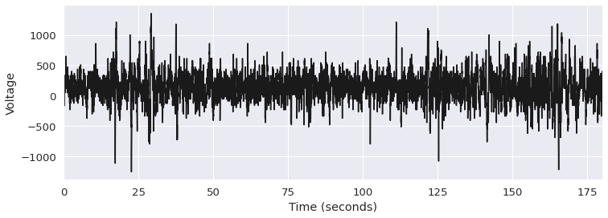

Figure 4a: Raw EEG data in human brain waves

For examining, visualizing, and interpreting human neurophysiological data, such as EEG, MNE is an open-source Python library. We can use the mne.io.RawArray function to create the raw object. Then we can call the raw.plot() command and it could be plotted in figure 4b.

Figure 4b: Raw EEG data plotted for visual inspection

As we can see F4 was a bad channel with flat readings for a long period. Using visual Inspection, such bad channels could be manually removed.

**Data Pre-processing:**

Preprocessing is the process of converting unprocessed data into a form that is more suited for further analysis in machine learning. Preprocessing in the context of EEG data typically refers to the removal of noise to bring actual neural signals closer to the true brain frequencies. During states of attention, the brain generates EEG waves with correlated signal frequencies that are primarily concentrated below 40 Hz. Therefore, the 2–40 Hz range is the appropriate frequency region for EEG signal data (Abeer-Al-Nafjan, A., & Aldayel, M., 2022). And, by isolating signals from the temporally and functionally unrelated brain and non-brain source processes, Independent Component Analysis (ICA) has been shown to be a successful data-driven method for studying EEG data, expanding its definition (Chilkur, T. 2021). Therefore, we chose these methods of filtering and ICA as part of data pre-processing.

**Feature selection and extraction:** Building EEG-based BCI applications rely greatly on feature extraction. Power spectral density (PSD) is a frequency-based measure of signal strength. It is based on frequency domain analysis and is one of the most often used feature extraction techniques in EEG-based research data (Abeer-Al-Nafjan, A., & Aldayel, M., 2022). Using the PSD method, data is converted from the time domain to the frequency domain and back again. The fast Fourier transform (FFT), which measures the discrete transformation of a Fourier series and its opposite, is the foundation for this conversion data (Abeer-Al-Nafjan, A., & Aldayel, M., 2022). Main frequency band frequencies existing in human brain activity are displayed in figure 5 (Moreno Escobar, J. J. et al., 2020). Power spectral density was estimated using Welch’s method to compute the absolute power of the brain signal frequencies by approximating the area under the curve. Band powers of Alpha (α), Beta (β), Gamma (γ), Delta (δ), and Theta (θ) bands were extracted (Figure 5) as they help in the identification of ADHD.

Figure 5: Frequency bands in human brain waves

Thereafter, CSV files were created for each channel which contains the absolute band wave values. We concatenated as per the binary class into ADHD and non-ADHD and a new dataset was created with extracted band waves using the TensorFlow library. These values were fed into the ML models thereafter. As mentioned before, theta activity increases, and beta activity in the brain dramatically reduces in ADHD, Theta to Beta ratio is a good indication of ADHD. Thus, a spectral analysis was done on theta/beta ratio (TBR) – an index of inattention and we inputted the model with this data as well.

**Development and training of MLP classifier in Python:** A neural network model was made using TensorFlow and Keras libraries. The model was then optimized, and the loss function was estimated using Stochastic Gradient descent. The Binary Cross Entropy loss function was used for optimization using Stochastic Gradient descent. Thereafter, the model was trained (Train Set – 80%, Validation Set – 10%, & TestSet 10%) with a Batch size of 32 and epochs of 200 to perform binary classification.

**Model Evaluation:** Then this model was tested using the partitioned test data set and accuracy were calculated. A confusion matrix also was created from sklearn library functions to visualize the performance of the classification.

**Results and Discussion:**

Children are most frequently affected by ADHD, and early detection is crucial to avoiding consequences (Mohammadi et al., 2016). Using non-linear EEG signal characteristics, we created a neural network model in this paper to identify ADHD at an earlier stage. This system is built on neural networks and non-linear features. As explained in the above methodology section, after importing the .mat files and converting them to csv, a new dataset was produced using sing the TensorFlow library. To recap, 19 CSV files (one for each channel) were produced in Python. Then we imported the same to pass it into the neural network model that was made using TensorFlow and Keras libraries. Absolute and relative band values were computed using the signal function from the Scipy library applying Welch’s method, as in table 1.

Table 1: Extracted Spectral Features preview

Welch's periodogram is created by averaging successive Fourier transforms of contiguous or non-contiguous tiny windows of the signal. By segmenting the data into overlapping segments, creating a modified periodogram for each segment, then averaging the periodograms, Welch's method calculates an estimate of the power spectral density (P. Welch, 1967). Then the data was split in an 80:10:10 ratio between the train set, validation set, and test set. The Binary Cross Entropy loss function was used for optimization using Stochastic Gradient descent. When we ran the model using a batch size of 32 and epochs of 200, the model predicted ADHD with up to 69% accuracy (figure 6).

Figure 6: Frequency bands in human brain waves

Thus, without data pre-processing and even with an irregular EEG signal, it generated results with up to 70% accuracy. We also noted that the model was generating differing degrees of accuracy with each run.

To compare this result with the performance of other classifiers, we also did Python coding to create models in different other classifiers such as SVM, Random Forest, XGBoost, and Decision tree using the sklearn library. In these models, we also included the relative band waves (Table 1) for improved accuracy.

|  |  |
| --- | --- |
| **Classifier** | **Accuracy** |
| **KNN** | 75% |
| **Random Forest** | 73% |
| **MLPsklearn** | 72% |
| **SVM** | 71% |
| **XGBoost** | 71% |
| **Bagging** | 71% |
| **AdaBoost** | 70% |
| **Logistic Regression** | 68% |
| **Decision Tree** | 64% |
| **Naive Bayes** | 60% |

Table 2: Classifiers performance

Figure 7: Classifiers performance

We calculated the accuracy using the metrics function of the Sklearn library. As we can see in table 2 and figure 7, the study produced stable results. KNN and Random Forest performed at best (73%) whereas Decision Tree and Logistic Regression produced the least (60%). SVM, MLP, XGBoost, Bagging, and AdaBoost produced almost the same result (70%). The confusion matrix shown below in figures 8a and 8b shows that there was more error in predicting (184 vs 47). This could be because the number of records of ADHD taped in the experiment was 30% more than non-ADHD (Figure 8a, 8b).

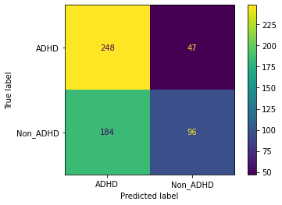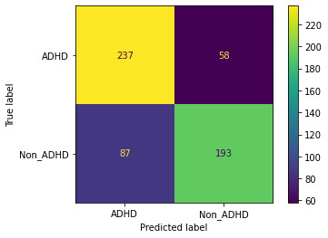

Figure 8a: KNN: 75%

Figure 8b: Naïve Bayes: 60%

Figure 8c: Classification Report

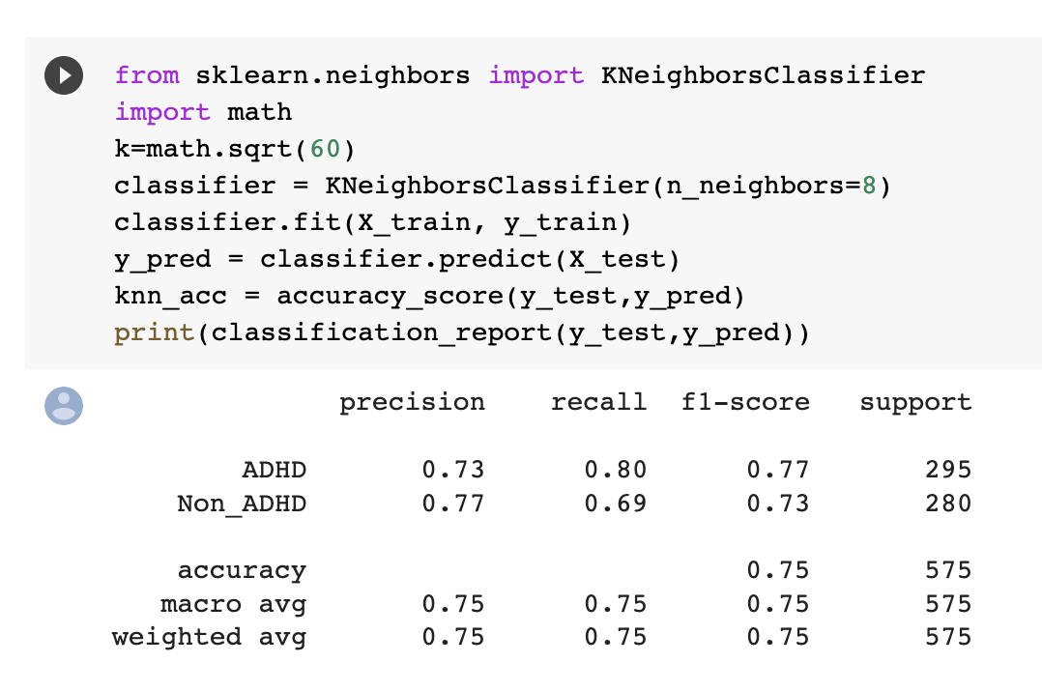

Figure 8c: Classification Report

As seen in figure 8c, the classification report produced an F1 score of 77, a precision of 73, and a recall of 80. F1 score gives a better performance measurement than accuracy in this case as the dataset is skewed to ADHD by over 30% of records. The precision score indicates that 73% of the positive predictions made were correct (true positives). Another useful measure to measure how good a test is recall or sensitivity at detecting the positives. It is a ratio of positive cases that are correctly predicted over all the positive cases. Thus, we can say 80% of the positive cases were predicted correctly.

In our further literature review, we analyzed the reason for this medium level of accuracy and instability. We found that data pre-processing of the EEG signals is crucial. EEG signals are very prone to noise from random natural processes, physiological and environmental artifacts, and external contaminants (figure 9). The original signal can be disturbed by these undesirable distortions that emerge in the transmission. Therefore, it is imperative to filter the artifacts that include noise from electrical lines, muscle movement, heartbeat, sweating, electrode movement, and so (Rastogi, A., & Bhateja, V. 2021). Feature eliminations using different component analysis such as PCA or ICA simplifies the complexity of high-dimensional data while retaining trends and patterns. To eliminate the redundancy caused by high-dimensional data, feature extraction can be applied to convert the current features into a lower-dimensional space (Subasi, A., & Gursoy, M. I., 2010).

In our initial stage, we had coded an MLP model with PCA and it was used to reduce the dimensionality of EEG data to classify them (included in the submission), but it was dropped since the model did not yield satisfactory accuracy levels. However, after the above literature review, we created another model in Python using the Sklearn library to analyze the effect of applying filter, ICA, band powers, and to apply multiple classifiers. We used the Butterworth filter function from the Scipy library for filtering, FastICA, a quick algorithm for Independent Component Analysis, for ICA, and the periodogram function from the Scipy signal for measuring the power spectral density.

Figure 9: EEG Artifacts

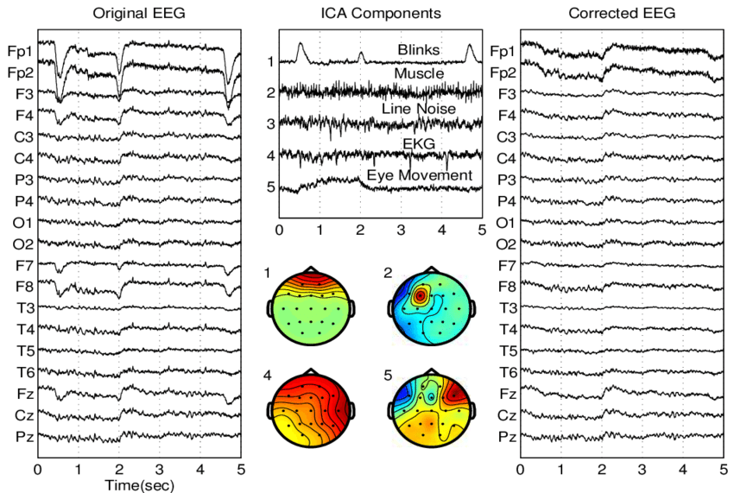

Then we applied various classifiers such as KNN, LightBGM, Logistic Regression, etc., and found that accuracy improved to almost 93% with the KNN classifier. (This notebook is still under development and can be submitted in the next phase of the research).

As seen in figure 10, the classification report produced an F1 score of 94, a precision of 89, and a recall of 1. F1 score gives a better performance measurement than accuracy in this case as the dataset is skewed to ADHD by over 30% of records. The precision score indicates that 89% of the positive predictions made were correct (true positives). Another useful measure to measure how good a test is recall or sensitivity at detecting the positives. It is a ratio of positive cases that are correctly predicted over all the positive cases. Thus, we can say 100% of the positive cases (non-ADHD) were predicted correctly.

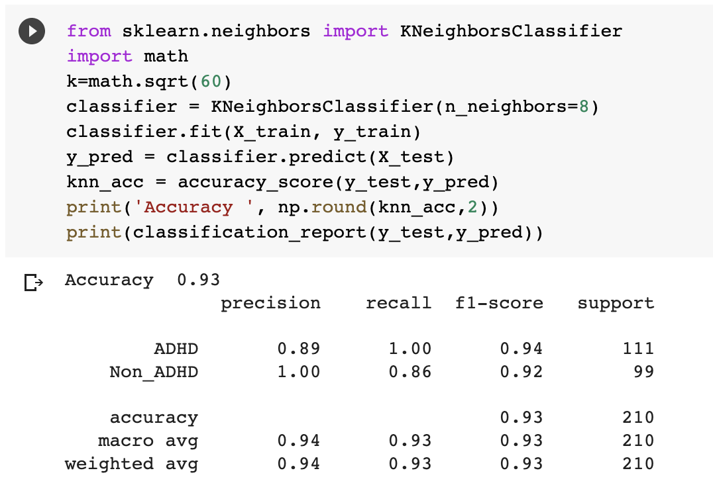

Figure 10: Classification Report

|  |  |
| --- | --- |
| **Classifier** | **Accuracy** |
| KNN | 93% |
| LightBGM | 91% |
| Logistic Regression | 43% |
| MLPClassifier | 43% |
| Random Forest | 43% |

Table 3: Classifiers performance with filtering

This study has certain limitations. Firstly, we have only a limited number of recordings in the chosen dataset. There are only a very few datasets available that focus on ADHD and attention as per our research. In the next phase, we would take IRB approval and conduct experiments to collect more data for deeper analysis and model performance.

**Conclusion:**

The goal of this study is to 1) use neural network classification ML algorithm to detect attention deficiency by using EEG dataset, and 2) analyze the impact of CM-II on individuals with attention deficiency. For goal 1, we used Multi-layer Perceptron (MLP), KNN, SVM, and other classifiers on bandwidths of α,β,δ,θ bands obtained from 19 channels of raw EEG dataset. The algorithm produces an accuracy of 93%. Given the accuracy could be improved, in the next phase of this research, we will run the study on live EEG data and will improve the model for higher accuracy. For goal 2, we will analyze the impact of CM-II on participants’ attention spans.

**Future Research:**

Application of band wave ratios and deeper spectral analysis could lead to extracting the most important information from the signals. It will be also interesting to study chaos in EEG as it has non-linear processes with high fluctuations. ConvLSTM is proven to provide high accuracy in ADHD predictions as per studies conducted in a few similar papers TaghiBeyglou, B et al., 2022, Bakhtyari, M., & Mirzaei, S. 2022, and Allahverdy, A et al., 2016). In the next phase, we intend to apply this classification algorithm to improve our model performance.

In the next phase, the data collection and running of the experiment phase, the study will continue to improve the model’s accuracy and stability. Then, an experiment will be conducted on 10-15 participants to analyze their live EEG scans to measure their attention deficiency as well as its improvement after CM-II meditation (Fig. 6). Diagram

Figure 11: Phase 2 Methodology

Even more, in phase II, we would adopt other metrics such as Heart Rate Variability (HRV) and Heart Coherence (HC) as well, which could be measured by smart technology to device a user-friendly technology in the measurement of attention deficiency to observe the effect of CM II meditation on the human state of mind. Additionally, we would also apply a CT test or self-efficacy test to measure the impact of attention before and after when the user is engaged in meditation. The result is expected to prove the hypothesis that CM-II meditation is expected to improve the level of attention in students.

References  
Mohammadi, M. R., Khaleghi, A., Nasrabadi, A. M., Rafieivand, S., Begol, M., & Zarafshan, H. (2016). EEG classification of ADHD and normal children using non-linear features and neural network. *Biomedical Engineering Letters*, *6*(2), 66-73.

Alchalabi, A. E., Shirmohammadi, S., Eddin, A. N., & Elsharnouby, M. (2018). FOCUS: Detecting ADHD patients by an EEG-based serious game. *IEEE Transactions on Instrumentation and Measurement*, *67*(7), 1512-1520.

P. Rego, P. M. Moreira, and L. P. Reis, Serious games for rehabilitation: A survey and a classification towards a taxonomy. *Proc. 5th Iberian Conf. Inf. Syst. Technol.*, 2010, pp. 1–6.

M. van Lambalgen, C. van Kruistum, and E. Parigger, Discourse processing in attention-deficit hyperactivity disorder (ADHD). *J. Logic, Lang. Inf.,* vol. 17, no. 4, pp. 467–487, Oct. 2008.

CDCP (Centers for Disease Control and Prevention). *Key Findings: Newborn Screening for Critical Congenital Heart Defects Now Common Throughout United States* | NCBDDD | CDC. Accessed: Nov. 15, 2016. [Online]. Available: http://www.cdc.gov/ncbddd/heartdefects/features/ kf-newborn-heart-screening-commom-us.html

APA., American Psychiatric Association. DSM-5 Task Force. *Diagnostic and statistical manual of mental disorders : DSM-5*. 5th edn. American Psychiatric Association, Washington, D.C. 2013.

Adler, L. A., Childress, A., Cloutier, M., Gagnon-Sanschagrin, P., Davidson, M., Kinkead, F., ... & Schein, J. (2021). *PMH4 economic burden of attention-deficit/hyperactivity disorder (ADHD) among adults in the United States: a societal perspective*. Value in Health, 24, S128.

Your team should be made up of 2/3 students

Jafari P, Ghanizadeh A, Akhondzadeh S, Mohammadi MR. *Health-related quality of life of Iranian children with attention deficit/hyperactivity disorder.* Qual Life Res. 2011; 20(1):31-6

Meysamie A, Fard MD, Mohammadi M-R. Prevalence of attention-deficit/hyperactivity disorder symptoms in preschoolaged Iranian children. *Iran J Pediatr*. 2011; 21(4):467.

Lubar JF. Discourse on the development of EEG diagnostics and biofeedback for attention-deficit/hyperactivity disorders. *Biofeedback Self-Reg* 1991; 16(3):201-25.

Fonseca LC, Tedrus GMA, Moraes Cd, Machado AdV, Almeida MPd, Oliveira DOFd. Epileptiform abnormalities and quantitative EEG in children with attention-deficit/hyperactivity disorder. *Arq Neuro-Psiquiat.* 2008; 66(3A):462-7.

Mueller A, Candrian G, Grane VA, Kropotov JD, Ponomarev VA, Baschera G-M. Discriminating between ADHD adults and controls using independent ERP components and a support vector machine: a validation study. *Nonlinear Biomed Phys.* 2011; 5(1):5.

Fried, R., DiSalvo, M., Farrell, A., & Biederman, J. (2022). Using a digital meditation application to mitigate anxiety and sleep problems in children with ADHD. *Journal of Attention Disorders*, 26(7), 1033-1039.

Economides, M., Martman, J., Bell, M. J., & Sanderson, B. (2018). Improvements in stress, affect, and irritability following brief use of a mindfulness-based smartphone app: a randomized controlled trial. *Mindfulness*, 9(5), 1584-1593, Chicago.

Kora, P., Meenakshi, K., Swaraja, K., Rajani, A., & Raju, M. S. (2021). EEG based interpretation of human brain activity during yoga and meditation using machine learning: A systematic review. *Complementary therapies in clinical practice*, 43, 101329.

Gopi, Sreekanth. (2020). Chakramarma Meditation - Vedic Transpersonal practices research.

Sarabia-Cobo, C. M. (2015). Heart coherence: a new tool in the management of stress on professionals and family caregivers of patients with dementia. *Applied psychophysiology and biofeedback*, 40(2), 75-83.

McCraty, R. (2022). Following the Rhythm of the Heart: HeartMath Institute’s Path to HRV Biofeedback. *Applied Psychophysiology and Biofeedback*, 1-12.

Nazhvani, A. D., Boostani, R., Afrasiabi, S., & Sadatnezhad, K. (2013). Classification of ADHD and BMD patients using visual evoked potential. *Clinical neurology and neurosurgery*, 115(11), 2329-2335 Chicago.

Slater, J., Joober, R., Koborsy, B. L., Mitchell, S., Sahlas, E., & Palmer, C. (2022). Can electroencephalography (EEG) identify ADHD subtypes? A systematic review. *medRxiv* Chicago.

Willson, S. (2021). Her breath in our holy bones: an intuitive inquiry into the lived experience of kundalini awakenings in Aotearoa, New Zealand from a critical health psychology perspective: a thesis presented in partial fulfilment of the degree of Master of Science in Health Psychology at *Massey University, Auckland, New Zealand* (Doctoral dissertation, Massey University).

Rogers, L., Phillips, K., & Cooper, N. (2021). Energy Healing Therapies: A Systematic Review and Critical Appraisal. *Health Psychology Review*, 2(3), 162-170.

Piha, K. (2022). Self-healing With Reiki for Homeless Individuals Suffering from Past Traumatic Events. Augsburg University, <https://idun.augsburg.edu/etd>.

Rand, W. L. (2013). History of Reiki. An evidence based history of Reiki: a selection of articles from *Reiki New Magazine*. Southfield: International Center for Reiki Training, 16-31.

Kason, Y. (1994). Near-death experiences and kundalini awakening: Exploring the link. *Journal of near-death studies*.

De Vitto, J. (2021). Reiki practitioners’ experiences of self-healing and transformation: An intuitive inquiry. *Consciousness, Spirituality & Transpersonal Psychology*, 2, 1-15.

Liu, W., Qiu, J. L., Zheng, W. L., & Lu, B. L. (2021). Comparing recognition performance and robustness of multimodal deep learning models for multimodal emotion recognition. *IEEE Transactions on Cognitive and Developmental Systems*.

Sadatnezhad, K., Boostani, R., & Ghanizadeh, A. (2011). Classification of BMD and ADHD patients using their EEG signals. *Expert Systems with Applications*, 38(3), 1956-1963.

Deolindo, C. S., Ribeiro, M. W., Aratanha, M. A., Afonso, R. F., Irrmischer, M., & Kozasa, E. H. (2020). A critical analysis on characterizing the meditation experience through the electroencephalogram. *Frontiers in systems neuroscience*, 14, 53.

Tenev, A., Markovska-Simoska, S., Kocarev, L., Pop-Jordanov, J., Müller, A., & Candrian, G. (2014). Machine learning approach for classification of ADHD adults. *International Journal of Psychophysiology*, 93(1), 162-166.

Kropotov, J. (2010). Quantitative EEG, event-related potentials and neurotherapy. *Academic Press.*

Nelles, O. (2020). *Nonlinear system identification: from classical approaches to neural networks, fuzzy models, and gaussian processes.* Springer Nature.

Radhamani, E., & Krishnaveni, K. (2016). Diagnosis and evaluation of ADHD using MLP and SVM classifiers. *Indian J Sci Technol*, 9(19), 93853.

Jolliffe, I.T.; Cadima, J. Principal component analysis: A review and recent developments. *Philos. Trans. R. Soc*. A 2016, 374, 20150202.

Kaur, A., & Kahlon, K. S. (2022). Accurate Identification of ADHD among Adults Using Real-Time Activity Data. *Brain Sciences*, 12(7), 831.

Ekhlasi, A., Nasrabadi, A. M., & Mohammadi, M. R. (2021). Direction of information flow between brain regions in ADHD and healthy children based on EEG by using directed phase transfer entropy. Cognitive Neurodynamics, 15(6), 975-986.

Zhang, D. W., Roodenrys, S., Li, H., Barry, R. J., Clarke, A. R., Wu, Z., ... & Sun, L. (2017). Atypical interference control in children with AD/HD with elevated theta/beta ratio. *Biological psychology*, 128, 82-88.

Shubham Dhuri, Nitin Ahire, Deepak Kamat, Sunil Nayak, Bhavesh Maurya. (2021). ADHD EEG signal analysis using Machine Learning. *International Research Journal of Engineering and Technology (IRJET)*, 128, 2572-2575.

TaghiBeyglou, B., Shahbazi, A., Bagheri, F., Akbarian, S., & Jahed, M. (2022). Detection of ADHD cases using CNN and classical classifiers of raw EEG. *Computer Methods and Programs in Biomedicine Update*, 100080.

Bakhtyari, M., & Mirzaei, S. (2022). ADHD detection using dynamic connectivity patterns of EEG data and ConvLSTM with attention framework. *Biomedical Signal Processing and Control*, 76, 103708.

Allahverdy, A., Moghadam, A. K., Mohammadi, M. R., & Nasrabadi, A. M. (2016). Detecting adhd children using the attention continuity as nonlinear feature of eeg. *Frontiers in Biomedical Technologies*, 3(1-2), 28-33.

Chen, H., Song, Y., & Li, X. (2019). Use of deep learning to detect personalized spatial-frequency abnormalities in EEGs of children with ADHD. *Journal of neural engineering*, 16(6), 066046.

Saccaro, L. F., Schilliger, Z., Perroud, N., & Piguet, C. (2021). Inflammation, anxiety, and stress in attention-deficit/hyperactivity disorder. *Biomedicines*, 9(10), 1313.

Liu, Q., Liu, Y., Leng, X., Han, J., Xia, F., & Chen, H. (2020). Impact of chronic stress on attention control: Evidence from behavioral and event-related potential analyses. *Neuroscience bulletin*, 36(11), 1395-1410. .

Eysenck MW, Derakshan N. New perspectives in attentional control theory. *Pers Individ Differ* 2011, 50: 955–960.

Krisanaprakornkit, T., Ngamjarus, C., Witoonchart, C., & Piyavhatkul, N. (2010). Meditation therapies for attention‐deficit/hyperactivity disorder (ADHD). *Cochrane Database of Systematic Reviews*, (6).

Abeer-Al-Nafjan, A., & Aldayel, M. (2022). Predict Students’ Attention in Online Learning Using EEG Data. *Sustainability*, 14(11), 6553.

Lusk, J. (2019, January 6). Yoga Nidra and Your Brain Wave Fluctuations. *Wholesome Resources*. Retrieved from <https://wholesomeresources.com/6044/yoga-nidra-and-your-brain-wave-fluctuations/>

Szafir, D., & Mutlu, B. (2012, May). Pay attention! Designing adaptive agents that monitor and improve user engagement. In Proceedings of the SIGCHI *conference on human factors in computing systems* (pp. 11-20).

Bitner, R. A., & Le, N. T. (2022). Can EEG-devices differentiate attention values between incorrect and correct solutions for problem-solving tasks?. *Journal of Information and Telecommunication*, 6(2), 121-140.

Harmony, T. (2013). The functional significance of delta oscillations in cognitive processing. *Frontiers in Integrative Neuroscience*, 7(83), 1–10.

Linden, M., Habib, T., & Radojevic, V. (1996). A controlled study of the effects of EEG biofeedback on cognition and behavior of children with attention deficit disorder and learning disabilities. *Biofeedback and Self-regulation*, 21(1), 35–49.

O’Connell, R. G., Dockree, P. M., Robertson, I. H., Bellgrove, M. A., Foxe, J. J., & Kelly, S. P. (2009). Uncovering the neural signature of lapsing attention: Electrophysiological signals predict errors up to 20 s before they occur. *Journal of Neuroscience*, 29(26), 8604–8611. https://doi.org/

10.1523/JNEUROSCI.5967-08.2009

Oken, B. S., Salinsky, M. C., & Elsas, S. (2006). Vigilance, alertness, or sustained attention: Physiological basis and measurement. *Clinical Neurophysiology*, 117(9), 1885–1901.

Arnsten, A. F. (2009). The emerging neurobiology of attention deficit hyperactivity disorder: the key role of the prefrontal association cortex. *The Journal of pediatrics*, 154(5), I.

Xia, S., Foxe, J. J., Sroubek, A. E., Branch, C., & Li, X. (2014). Topological organization of the “small-world” visual attention network in children with attention deficit/hyperactivity disorder (ADHD). *Frontiers in Human Neuroscience*, 8, 162.

Moreno Escobar, J. J., Morales Matamoros, O., Tejeida Padilla, R., Lina Reyes, I., Chanona Hernández, L., & Ramírez Gutiérrez, A. G. (2020). Brain-inspired healthcare smart system based on perception-action cycle. *Applied Sciences*, 10(10), 3532.

Acı, Ç. İ., Kaya, M., & Mishchenko, Y. (2019). Distinguishing mental attention states of humans via an EEG-based passive BCI using machine learning methods. *Expert Systems with Applications*, 134, 153-166.

P. Welch, “The use of the fast Fourier transform for the estimation of power spectra: A method based on time averaging over short, modified periodograms”, *IEEE Trans. Audio Electroacoust.* vol. 15, pp. 70-73, 1967.

Rastogi, A., & Bhateja, V. (2021). Pre-processing of electroencephalography signals using stationary wavelet transform-enhanced fixed-point fast-ICA. *In Data Engineering and Intelligent Computing* (pp. 387-396). Springer, Singapore.

Subasi, A., & Gursoy, M. I. (2010). EEG signal classification using PCA, ICA, LDA and support vector machines. *Expert systems with applications*, 37(12), 8659-8666.

Dataset and Code references:

Aci, C. I. (2018, December 15). EEG data for Mental Attention State Detection. Retrieved from https://www.kaggle.com/datasets/inancigdem/eeg-data-for-mental-attention-state-detection

Chilkur, T. (2021, December 1). ICA for EEG. Retrieved from https://www.kaggle.com/code/tarunchilkur/ica-for-eeg/notebook

Ali Motie Nasrabadi, Armin Allahverdy, Mehdi Samavati, Mohammad Reza Mohammadi. (2020). EEG data for ADHD / Control children. IEEE Dataport. https://dx.doi.org/10.21227/rzfh-zn36